

Intelligent Airport Baggage Tracking and Logistics Management Platform
A REPORT
In
CSA1012 –Software Engineering
Submitted in the partial fulfillment for the award of the degree
Of
BACHELOR OF ENGINEERING
IN
INFORMATION TECHNOLOGY
Submitted by:
K.Nanda Kishore Reddy (192411161)

Supervisor/Advisor Name:
Dr. K. Anita Devamani,
Professor/CSE

SAVEETHA INSTITUTE OF MEDICAL AND TECHNICAL SCIENCES
CHENNAI-602105

INDEX
S. No. | Contents | Page No.
1 | Introduction | 1
2 | Problem Statement Recap | 2
3 | Objectives Mapped to Git & Docker | 2
4 | System Architecture Overview | 3
5 | Repository Structure | 4
6 | Git Branching Strategy | 5
7 | Core Git Workflow & Commands | 6
8 | .gitignore | 7
9 | Commit Message Convention | 7
10 | Docker Container Architecture | 8
11 | Dockerfiles | 9
12 | docker-compose.yml | 10
13 | Build, Run & Verify Commands | 11
14 | Volumes & Data Persistence | 11
15 | Health Checks & High Availability | 12
16 | Git + Docker CI/CD Pipeline | 13
17 | Security Considerations | 14
18 | Benefits of Git & Docker | 15
19 | Challenges & Improvements | 16
20 | Conclusion | 17
21 | References | 18

INTELLIGENT AIRPORT BAGGAGE TRACKING AND LOGISTICS MANAGEMENT PLATFORM
1. Introduction
The Intelligent Airport Baggage Tracking and Logistics Management Platform is a software system designed to monitor and manage passenger baggage throughout the airport handling process. Baggage passes through several stages including check-in, security screening, sorting, transportation, aircraft loading, unloading, and baggage collection.
In traditional baggage-handling systems, difficulties such as misplaced baggage, incorrect routing, delayed transportation, and lack of real-time visibility can affect airport operations and passenger satisfaction. The proposed platform provides a centralized system for tracking baggage movement and managing airport logistics.
The system can use baggage identification technologies such as barcode or RFID scanning to identify individual baggage items. Each baggage movement can be recorded with information such as baggage ID, flight number, current location, status, and timestamp.
This assignment focuses on applying Git for version control and Docker for containerization during the development and deployment of the platform. The assignment covers repository organization, branching strategy, Git commands, Dockerfiles, Docker Compose, deployment, testing, security, and CI/CD.
The assignment structure is aligned with the supplied technical-assignment requirements, which expect a technical report, Git repository, source code, Dockerfile, Docker Compose configuration, screenshots, and architecture/workflow diagrams.

2. Problem Statement Recap
Airports handle a large number of baggage items every day. Baggage must be correctly identified, sorted, transported, loaded onto aircraft, unloaded, and delivered to passengers.
A failure at any stage may result in:
- Misplaced baggage
- Delayed baggage
- Incorrect baggage routing
- Loss of baggage location information
- Poor coordination between airport departments
- Difficulty in identifying baggage-handling problems
- Delayed response to baggage exceptions
The proposed Intelligent Airport Baggage Tracking and Logistics Management Platform addresses these problems by providing continuous baggage tracking and centralized logistics management.
The system should:
- Register baggage information.
- Track baggage movement between airport locations.
- Maintain baggage status and history.
- Connect baggage information with flight information.
- Support airport logistics operations.
- Detect baggage delays or routing problems.
- Provide notifications to authorized staff.
- Provide a dashboard for monitoring baggage.
- Store historical tracking information.
- Support scalable and reliable deployment.

3. Objectives Mapped to Git & Docker
Objective | Git/Docker Implementation
Real-time baggage tracking | Baggage tracking service is maintained as an independent application component and container.
Baggage identification | Tracking code and scanning functionality are maintained under Git version control.
Logistics management | Logistics service can be developed and deployed independently.
Baggage status monitoring | Backend service maintains baggage status and tracking history.
Notification management | Notification service can be independently updated and scaled.
Airport dashboard | Dashboard is packaged as a separate Docker container.
Centralized database | Database runs in a dedicated container with persistent storage.
Collaborative development | Git branches allow developers to work on individual features.
Reliable deployment | Docker provides a consistent runtime environment.
Continuous integration | Git changes can trigger automated testing and Docker image building.
Scalability | Individual services can be scaled according to workload.
Maintainability | Git history and modular Docker services simplify maintenance.

4. System Architecture Overview

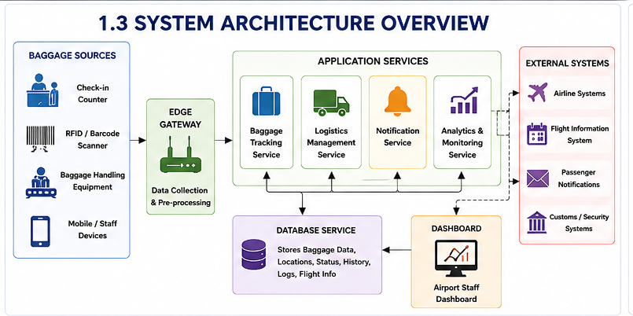

5. Repository Structure

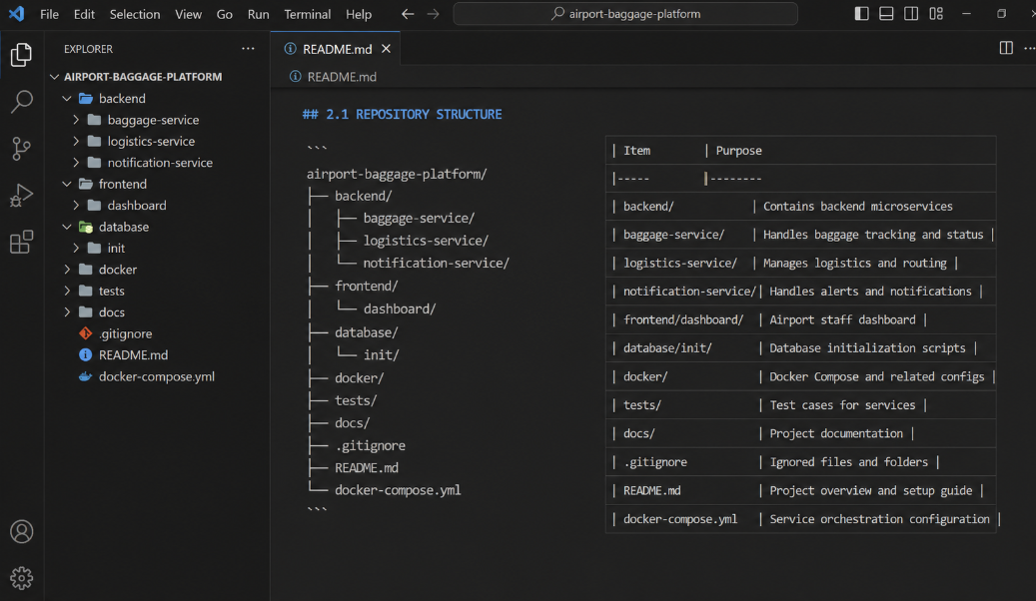

6. Git Branching Strategy
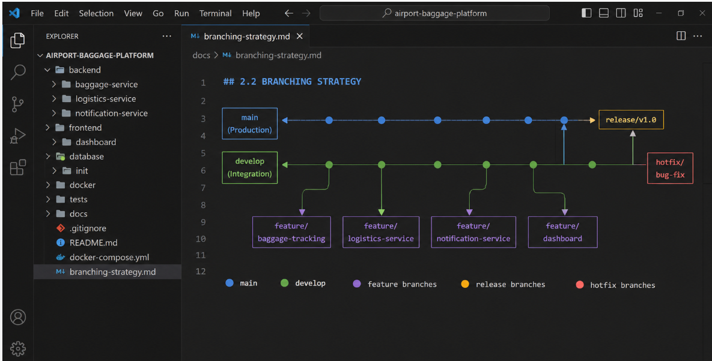

7. Core Git Workflow & Commands
7.1 Initialize Repository
mkdir airport-baggage-platform
cd airport-baggage-platform

git init
The git init command creates a new Git repository.
7.2 Add Files
git add .
This stages the project files for committing.
7.3 Create Commit
git commit -m "chore: initialize airport baggage platform"
A commit stores a versioned snapshot of the project.
7.4 Connect Remote Repository
git remote add origin <repository-url>
7.5 Push Code
git push -u origin main
7.6 Create Feature Branch
git checkout develop
git checkout -b feature/baggage-tracking
7.7 Commit Feature
git add .
git commit -m "feat(baggage): add baggage tracking service"
7.8 Push Feature Branch
git push -u origin feature/baggage-tracking
7.9 Merge Feature
git checkout develop
git merge feature/baggage-tracking
git push origin develop
7.10 View History
git log --oneline
7.11 View Branches
git branch
7.12 Check Status
git status
These operations demonstrate repository initialization, branch creation, commits, merging, and synchronization, which are part of the assessment requirements.

8. .gitignore
The .gitignore file specifies files and directories that should not be tracked by Git.
Example:
# Python
__pycache__/
*.pyc
venv/

# Node
node_modules/
npm-debug.log

# Environment files
.env
.env.*

# IDE
.vscode/
.idea/

# Logs
*.log

# Operating System
.DS_Store
Thumbs.db
Importance
The .gitignore file helps to:
- Avoid committing unnecessary files.
- Reduce repository size.
- Protect sensitive configuration.
- Avoid uploading dependencies.
- Keep the repository organized.
Passwords, API keys, database credentials, and other sensitive information should not be committed to Git.

9. Commit Message Convention
The project follows a meaningful commit message convention.
Type | Purpose | Example
feat | New functionality | feat(baggage): add tracking API
fix | Bug correction | fix(logistics): correct routing status
docs | Documentation | docs: update architecture diagram
test | Testing | test(baggage): add tracking tests
refactor | Code restructuring | refactor(logistics): simplify routing
chore | Configuration | chore(docker): add compose file

Example Commit History
feat(baggage): add baggage tracking API
feat(logistics): add baggage routing service
feat(notification): add delay notifications
feat(dashboard): add baggage monitoring screen
test(baggage): add tracking API tests
chore(docker): add Docker Compose configuration
fix(logistics): correct baggage routing status
Meaningful commit messages make the development history easier to understand and maintain. The assessment also evaluates the quality of commit history and professional commit messages.

10. Docker Container Architecture
Docker is used to package the application components into independent containers.
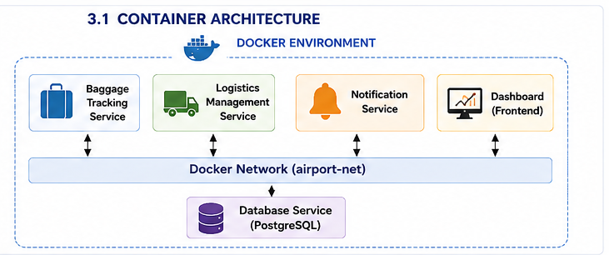

Advantages
Each service is isolated and can be:
- Built independently.
- Tested independently.
- Restarted independently.
- Updated independently.
- Scaled independently.
Docker is appropriate for this project because the assessment expects containerization of the required application components and an explanation of why Docker is suitable.

11. Dockerfiles
11.1 Baggage Tracking Service
FROM python:3.11-slim

WORKDIR /app

COPY requirements.txt .

RUN pip install --no-cache-dir -r requirements.txt

COPY . .

EXPOSE 8000

CMD ["python", "app.py"]
Explanation
- FROM selects the base Python image.
- WORKDIR sets the application directory.
- COPY copies required files.
- RUN installs dependencies.
- EXPOSE defines the application port.
- CMD starts the application.
11.2 Logistics Service
FROM python:3.11-slim

WORKDIR /app

COPY requirements.txt .

RUN pip install --no-cache-dir -r requirements.txt

COPY . .

EXPOSE 8001

CMD ["python", "app.py"]
11.3 Dashboard
FROM node:20 AS build

WORKDIR /app

COPY package*.json ./
RUN npm install

COPY . .
RUN npm run build

FROM nginx:alpine

COPY --from=build /app/dist /usr/share/nginx/html

EXPOSE 80

CMD ["nginx", "-g", "daemon off;"]
The Dockerfiles demonstrate the basic instructions required for creating container images. The assessment requires both the Dockerfile and an explanation of its instructions.

12. docker-compose.yml
Docker Compose is used to define and manage multiple services.
services:

baggage-service:
build: ./backend/baggage-service
ports:
- "8000:8000"
depends_on:
- database
networks:
- airport-net

logistics-service:
build: ./backend/logistics-service
ports:
- "8001:8001"
depends_on:
- database
networks:
- airport-net

notification-service:
build: ./backend/notification-service
ports:
- "8002:8002"
networks:
- airport-net

dashboard:
build: ./frontend/dashboard
ports:
- "3000:80"
depends_on:
- baggage-service
- logistics-service
networks:
- airport-net

database:
image: postgres:16
environment:
POSTGRES_DB: baggage_db
POSTGRES_USER: baggage_user
POSTGRES_PASSWORD: baggage_password
volumes:
- baggage-data:/var/lib/postgresql/data
networks:
- airport-net

volumes:
baggage-data:

networks:
airport-net:
Main Components
Component | Purpose
Baggage Service | Tracks baggage.
Logistics Service | Manages baggage routing.
Notification Service | Generates alerts.
Dashboard | Provides user interface.
Database | Stores system data.
Volume | Maintains database persistence.
Network | Enables service communication.

13. Build, Run & Verify Commands
Build Images
docker compose build
This builds Docker images for the application services.
Start Containers
docker compose up -d
The -d option runs the containers in detached mode.
Check Containers
docker compose ps
This displays the running services.
View Logs
docker compose logs
For a specific service:
docker compose logs baggage-service
Rebuild and Start
docker compose up -d --build
Stop Containers
docker compose down
Verify
The application can be verified by:
- Checking container status.
- Checking service logs.
- Opening the dashboard.
- Testing baggage tracking functionality.
- Testing logistics operations.
- Checking database connectivity.
- Checking notification functionality.
The assessment requires demonstration of container execution and evidence that the application runs successfully.

14. Volumes & Data Persistence
The baggage platform contains important information such as:
- Baggage records
- Baggage status
- Location history
- Flight information
- Logistics records
- Event history
This information should remain available even when containers are stopped or recreated.
Docker volumes provide persistent storage.
volumes:
baggage-data:
The volume can be mounted into PostgreSQL:
volumes:
- baggage-data:/var/lib/postgresql/data

15. Health Checks & High Availability
Health checks allow the system to determine whether a service is operating correctly.
Example:
healthcheck:
test: ["CMD", "curl", "-f", "http://localhost:8000/health"]
interval: 30s
timeout: 10s
retries: 3
The service can provide:
GET /health
Example response:
{
"status": "healthy"
}
High Availability
For high availability, multiple instances of a service can be deployed.
docker compose up -d --scale baggage-service=2
This provides multiple instances of the baggage service.
If one instance becomes unavailable, another instance can continue processing requests, depending on the deployment/load-balancing configuration.
Health checks and scalable services improve the reliability of the baggage platform.

16. Git + Docker CI/CD Pipeline
Git and Docker can be integrated into a CI/CD pipeline.
CI/CD Process
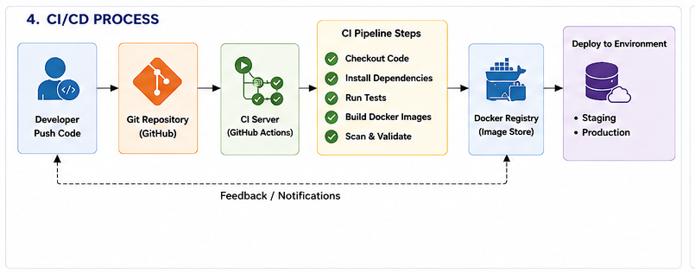

17. Security Considerations
Security is important because the platform may process passenger, baggage, flight, and operational information.
17.1 Secure Credentials
Database passwords and API keys should not be stored directly in source code.
Use:
Environment Variables
.env files
Docker Secrets
Secret Management Systems
17.2 Git Security
The main branch should be protected.
Important changes should require:
- Pull requests
- Code review
- Automated tests
- Approval
17.3 Container Security
Use lightweight and trusted base images.
Containers should run with only the permissions required by the application.
17.4 Network Security
The database should not be directly exposed to the public internet.
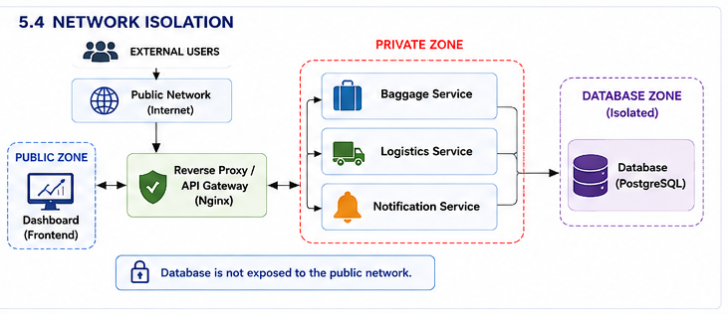

17.5 Data Protection
Sensitive information should be protected through:
- Authentication
- Authorization
- Encryption
- Secure API communication
- Access control
- Proper logging

18. Benefits of Git & Docker
Benefits of Git
Git provides:
- Version control
- Collaboration
- Branch management
- Code history
- Rollback capability
- Code review
- Change tracking
Benefits of Docker
Docker provides:
- Portability
- Environment consistency
- Application isolation
- Easy deployment
- Dependency management
- Scalability
- Reproducibility

19. Challenges & Improvements
19.1 Challenges
Git Challenges
- Managing multiple branches
- Merge conflicts
- Maintaining clean commit history
- Coordinating multiple developers
- Protecting sensitive configuration
Docker Challenges
- Container networking
- Service dependencies
- Database persistence
- Image size management
- Container debugging
- Environment configuration
Deployment Challenges
- Maintaining consistent environments
- Monitoring multiple services
- Scaling according to airport workload
- Handling service failures
- Managing deployment versions
19.2 Improvements
Future improvements can include:
- Kubernetes-based container orchestration.
- Cloud-based deployment.
- Automated infrastructure provisioning.
- Advanced monitoring and logging.
- Automated security scanning.
- RFID-based baggage identification.
- AI-based baggage delay prediction.
- Real-time logistics optimization.
- Automated passenger notifications.
- Multi-airport deployment.
The assessment specifically requires identifying implementation challenges and suggesting future improvements for Git workflow and Docker deployment.

20. Conclusion
The Intelligent Airport Baggage Tracking and Logistics Management Platform provides a centralized approach for tracking baggage and managing airport logistics operations.
The use of Git provides an organized software development environment with version control, branching, collaboration, meaningful commit history, and rollback capabilities. The selected branching strategy allows developers to work independently on baggage tracking, logistics, notification, and dashboard functionality while maintaining stable production code.
Docker provides a consistent and portable runtime environment by packaging the different application components into independent containers. Docker Compose simplifies the management of the baggage tracking service, logistics service, notification service, dashboard, and database.
Persistent volumes protect important baggage and logistics data, while health checks and service scaling improve reliability. Integrating Git and Docker with a CI/CD pipeline enables automated testing, image building, validation, and deployment.
Therefore, Git and Docker together provide a strong foundation for developing, testing, deploying, and maintaining the Intelligent Airport Baggage Tracking and Logistics Management Platform.

21. References
- Git Documentation. Git – Reference Manual. Available at:
- GitHub Documentation. GitHub Docs – Git Guides and Repository Management. Available at:
- Docker Documentation. Docker Documentation – Containers, Images and Docker Engine. Available at:
- Docker Documentation. Docker Compose – Define and Run Multi-Container Applications. Available at:
- Docker Documentation. Dockerfile Reference. Available at:
- GitHub Documentation. GitHub Actions – Automate Workflows and CI/CD. Available at:
- PostgreSQL Documentation. PostgreSQL Documentation. Available at:
- CSA1012 – Software Engineering: Git & Docker Technical Assignment, course-provided assignment document. The assignment specifies the required Git repository, branching strategy, Dockerfile, Docker Compose, deployment/testing, benefits, challenges, and future improvements.

